Making a Quiz for a classmate

*By Ava Hammer*

# Section 1: Parts of a Whole

Write the fraction

1.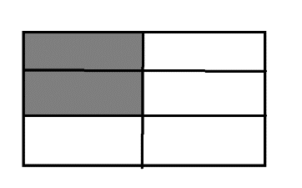 ______________

2. 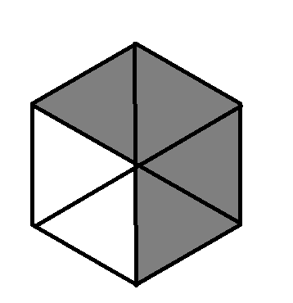 ________________

# Section 2: Part of a Set

Write the fraction that names the part

3.What fraction are **Blue**?

 ___________

4.Whate fraction are **White**?

 ___________

# Section 3: Fraction of a Set

Circle the sets. Write the answer

5. Circle 3 sets to find thirds. 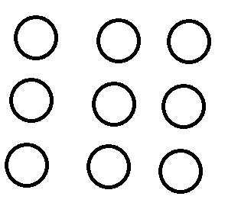  of 9 = _____

# Section 4: Compare & Order

Write the fractions in order from least to greatest

6.  ____ ____ ____

7. 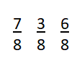 ____ ____ ____

# Section 5: Fraction Addition

Add the fractions together

8. 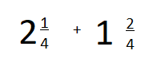 ______________

9.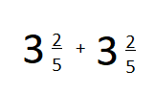 __________________

10. 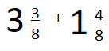 ________________

# Answer Key

**1. 2/6**

**2. 4/6**

**3. 3/5**

**4. 2/9**

**5. 3**

**6. 1/4, 3/4, 4/4**

**7. 3/8, 6/8, 7/8**

**8. 3 3/4**

**9. 6 4/5**

**10. 4 7/8**